TASK 1: Born Rule - Measurement Probabilities

Aim: To verify the Born Rule in quantum mechanics by calculating measurement probabilities for different superposition states.
- Theory:
In quantum mechanics, the Born Rule states that the probability of measuring a quantum system in a particular basis state is given by the square of the magnitude of its amplitude in that state. For a quantum state |ψ■ = Σ i α i |i■, the probability of measuring |i■ is: P(i) = |α i |² and the total probability must satisfy ΣP(i) = 1. This rule is fundamental to quantum mechanics, as it connects the abstract state vector with measurable outcomes.
2. Algorithm:
1.Define quantum states as complex vectors.
2. Apply the Born rule formula P = |ψ|² to calculate probabilities.
3. Normalize the probability distribution.
4. Visualize measurement probabilities using bar graphs.
3.program:
import numpy as np
import matplotlib.pyplot as plt
# Program: print("\n" + "="*50)
print("TASK 1: BORN RULE - MEASUREMENT PROBABILITIES")
print("="*50)
def born_rule_probabilities(psi):
"""Calculate measurement probabilities using Born rule: P = |<basis|psi>|^2"""
probabilities = np.abs(psi)**2 return probabilities / np.sum(probabilities) # Normalize
# Create superposition states
psi_1 = np.array([1/np.sqrt(2), 1/np.sqrt(2)]) # |+⟩ stateuymm
psi_2 = np.array([1/np.sqrt(3), np.sqrt(2/3)]) # Custom superposition
print("Superposition state 1: |ψ₁⟩ =", psi_1)
print("Measurement probabilities:", born_rule_probabilities(psi_1))
print("Superposition state 2: |ψ₂⟩ =", psi_2)
print("Measurement probabilities:", born_rule_probabilities(psi_2)) # Visualization states = ['|0⟩', '|1⟩']
probs_1 = born_rule_probabilities(psi_1)
probs_2 = born_rule_probabilities(psi_2)
plt.figure(figsize=(10, 4))
plt.subplot(1, 2, 1)
plt.bar(states, probs_1, color='blue', alpha=0.7)
plt.title('State |ψ₁⟩ Probabilities')
plt.ylabel('Probability')
plt.subplot(1, 2, 2)
plt.bar(states, probs_2, color='red', alpha=0.7)
plt.title('State |ψ₂⟩ Probabilities')
plt.ylabel('Probability')
plt.tight_layout()
plt.show()
output:
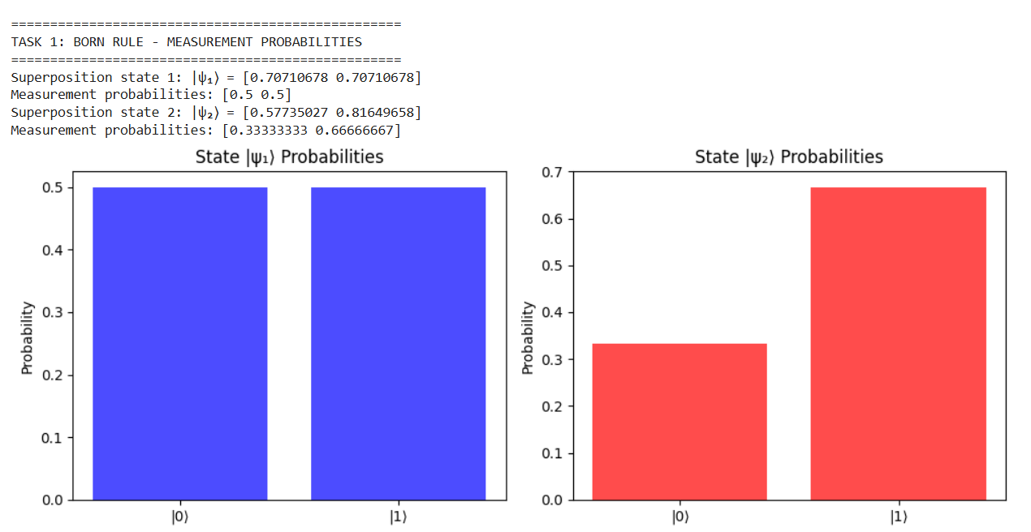
4.result:
The experiment verifies that measurement probabilities in quantum mechanics are determined by the square of the amplitude magnitudes of the state vector components, as described by the Born Rule.

